EX 3 COMPARISON OF SGD WITH MOMENTUM VS ADAM OPTIMIZER DATE:
Problem Statement:
Implement a training algorithm using Stochastic Gradient Descent (SGD) with momentum and compare it with the Adam optimizer. Train both models on a dataset and compare their convergence rates and performance.
Suggested Dataset: CIFAR-10
Objectives:
- Understand the principles of optimization algorithms in deep learning.
- Implement and train models using SGD with momentum and Adam.
- Analyze and compare the learning behavior and convergence patterns of the two optimizers.
- Visualize loss and accuracy across epochs for both optimization methods.
Scope:
This experiment gives students a comparative understanding of two widely used optimization strategies: SGD with momentum and Adam. Using a basic MLP and the CIFAR-10 dataset, students will learn the impact of optimizer choice on model convergence and final accuracy.
Tools and Libraries Used:
- Python 3.x
- PyTorch
- Matplotlib
- torchvision (for CIFAR-10 dataset) Implementation Steps:
Step 1: Import Necessary Libraries
import torch import torch.nn as nn import torch.optim as optim import torchvision
import torchvision.transforms as transforms import matplotlib.pyplot as plt
Step 2: Set Device and Load Dataset
device = torch.device("cuda" if torch.cuda.is_available() else "cpu")

transform = transforms.Compose([ transforms.ToTensor(), transforms.Normalize((0.5,), (0.5,)) ])
trainset = torchvision.datasets.CIFAR10(root='./data', train=True, transform=transform, download=True) trainloader = torch.utils.data.DataLoader(trainset, batch_size=128, shuffle=True) Step 3: Define MLP Model
class MLP(nn.Module): def __init__(self): super().__init__() self.flatten = nn.Flatten() self.net = nn.Sequential( nn.Linear(3*32*32, 256),
nn.ReLU(), nn.Linear(256, 10)
)

def forward(self, x): x = self.flatten(x) return self.net(x)
Step 4: Define Training Function
def train(model, optimizer, epochs=10): model.to(device)
loss_fn = nn.CrossEntropyLoss() losses = []
accuracies = []

for epoch in range(epochs):
total_loss = 0 correct = 0 total = 0 model.train()

for imgs, labels in trainloader: imgs, labels = imgs.to(device), labels.to(device)

outputs = model(imgs) loss = loss_fn(outputs, labels)

optimizer.zero_grad() loss.backward()
optimizer.step()

total_loss += loss.item() _, predicted = outputs.max(1)
total += labels.size(0)
correct += (predicted == labels).sum().item()

avg_loss = total_loss / len(trainloader) accuracy = 100.0 * correct / total

losses.append(avg_loss)
accuracies.append(accuracy)

print(f"Epoch {epoch+1}: Loss = {avg_loss:.4f}, Accuracy = {accuracy:.2f}%")

return losses, accuracies
Step 5: Train with SGD + Momentum and with Adam
model_sgd = MLP()
sgd = optim.SGD(model_sgd.parameters(), lr=0.01, momentum=0.9)
losses_sgd, acc_sgd = train(model_sgd, sgd)
model_adam = MLP() adam = optim.Adam(model_adam.parameters(), lr=0.001) losses_adam, acc_adam = train(model_adam, adam) Step 6: Visualize Loss and Accuracy Comparison
plt.figure(figsize=(12, 5))

plt.subplot(1, 2, 1)
plt.plot(losses_sgd, label="SGD + Momentum") plt.plot(losses_adam, label="Adam") plt.xlabel("Epoch") plt.ylabel("Loss")
plt.title("Loss Comparison on CIFAR-10 (MLP)") plt.legend()

plt.subplot(1, 2, 2)
plt.plot(acc_sgd, label="SGD + Momentum") plt.plot(acc_adam, label="Adam")
plt.xlabel("Epoch") plt.ylabel("Accuracy (%)")
plt.title("Accuracy Comparison on CIFAR-10 (MLP)") plt.legend() plt.tight_layout()
plt.show()

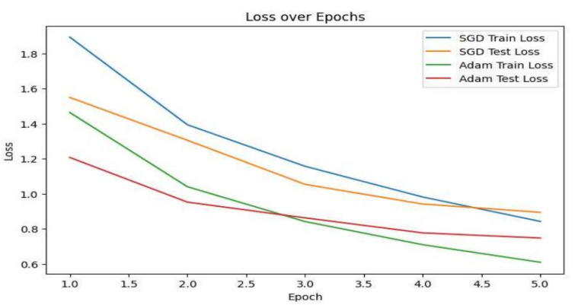
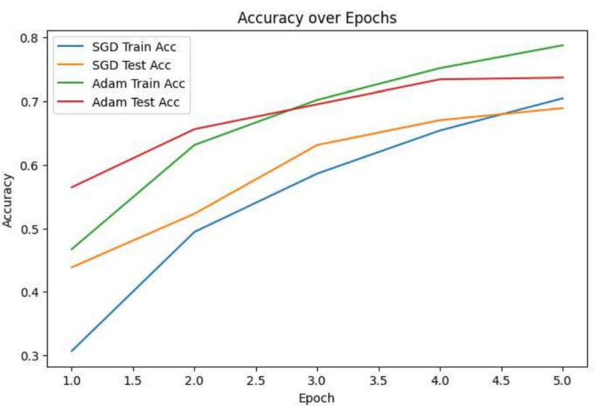

Conclusion:
This experiment shows a practical implementation of two optimization techniques and highlights their impact on model performance. Adam typically converges faster due to adaptive learning rates, while SGD with momentum offers more controlled, gradual learning. Choosing the right optimizer depends on the nature of the data and the task complexity.

